|  |  |
| --- | --- |
| *Pacific Gas and Electric Company* | |
| Release 8.4 Installation Guide | |
|  |  |
|  |  |
| Project | ED AM/GIS |
|  |  |
| Prepared by | Roger Carribine |
| Date | 6/5/2014 |
| Version | 1.0 |
| Version Type | Draft |

|  |  |  |  |
| --- | --- | --- | --- |
| Revision History | | | |
| Document # | Date | Author | Summary of Changes |
| 1.0 | 6/5/2014 | Roger Carribine | Initial Document Creation |
|  |  |  |  |

# Introduction

## Purpose

This document is intended to detail the implementation and configuration steps required to implement Release 8.4 Installation Guide. This document describes the various configuration aspects required to complete any manual or automatic patch associated with this release. Each section in this document contains the steps required to patch the system in production.

## Terms Used

|  |  |
| --- | --- |
| OOTB | Out of the box. Unmodified from the commercial version. |
| TFS | Team Foundation Server |

## External Documents

Referenced are any external configuration documents or exports. These are documents that contain more detailed information about configuring a system or documents that can be loaded into an application to perform the configuration detailed in this document.

## Summary of Steps to Complete Patch

These are the high-level steps to complete the installation and configuration of the data model patch. Use this table as a guide for completing the installation. Links are provided that can lead either within the document for detailed explanations or to external sites such as Sharepoint.

Table of Contents

1 Introduction 3

1.1 Purpose 3

1.2 Terms Used 3

1.3 External Documents 3

1.4 Summary of Steps to Complete Patch 4

2 Open a Database Connection in ArcCatalog 6

3 Create Classes/Fields 7

3.1 Create the following feature classes in the ElectricDataset: 7

4 Add GlobalIDs 12

5 Apply Permissions 13

5.1 Apply Permissions to the new Cross Section Annotation Classes 13

6 ArcFM Properties 14

6.1 Make the ConduitSystem Direction field visible: 14

7 Add Model Names 15

7.1 Add Custom UFM Object Model Names to the Model Name Domain 15

7.2 Add Custom UFM Field Model Names to the Model Name Domain 15

8 Assign Model Names 16

9 Update UFM Map Units 17

10 Update Data Model Version Table 18

11 Known Issues 19

# Open a Database Connection in ArcCatalog

1. Open ArcCatalog.
2. Within the Catalog Tree, expand “Database Connections” and open the active connection for this process. This is the connection that is referenced in the change request associated with this document (EDGIS<DB name in the format X#Y> )

# Create Classes/Fields

## Create the following feature classes in the ElectricDataset:

1. CrossSection50Anno
   * 1. Follow the below screens to create this new annotation feature class:

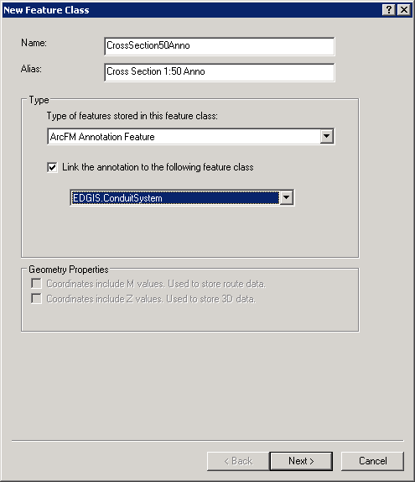

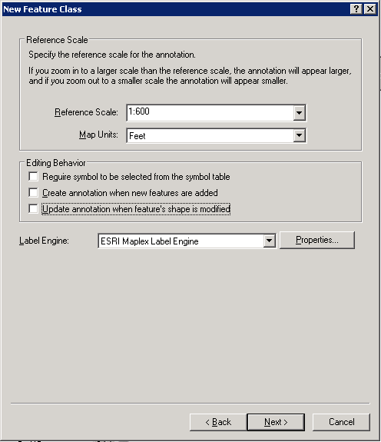

* + 1. No additional changes are required. Click next through the below screens and finish.
    2. Rename the relationship to “CrossSection50AnnoRel”

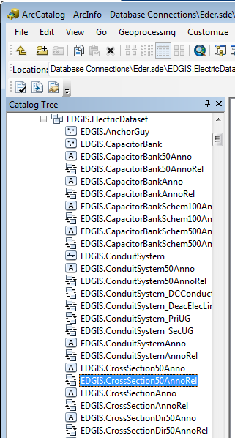

1. CrossSectionDirAnno
2. Follow the below screens to create this new annotation feature class:

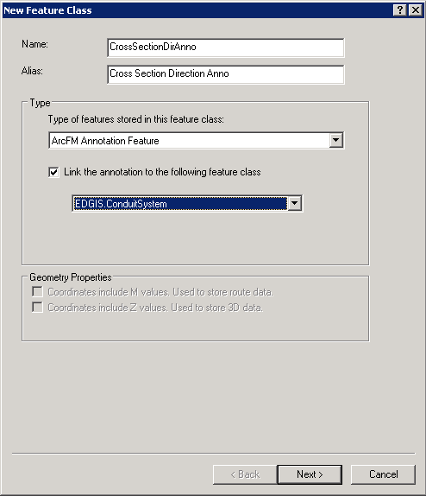

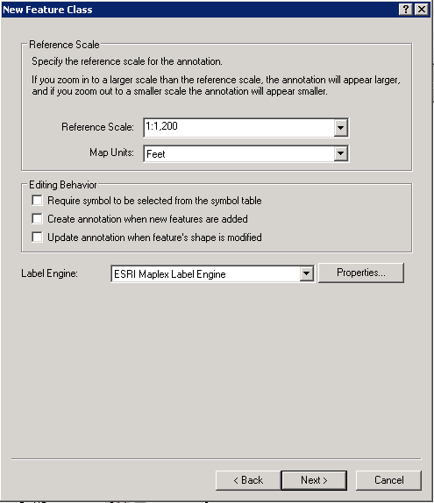

1. No additional changes are required. Click next through the below screens and finish.
2. Rename the relationship to “CrossSectionDirAnnoRel”

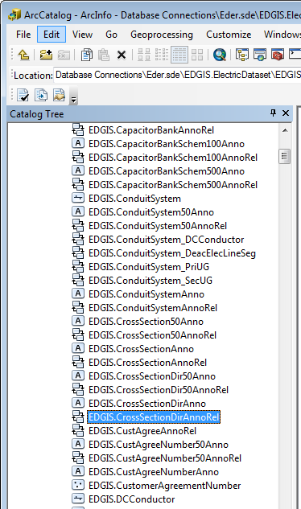

1. CrossSectionDir50Anno
2. Follow the below screens to create this new annotation feature class:

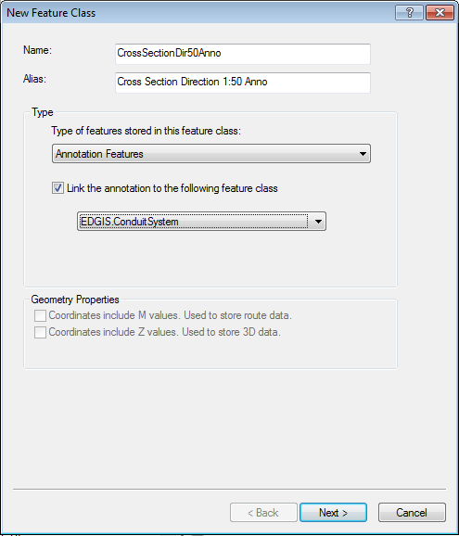

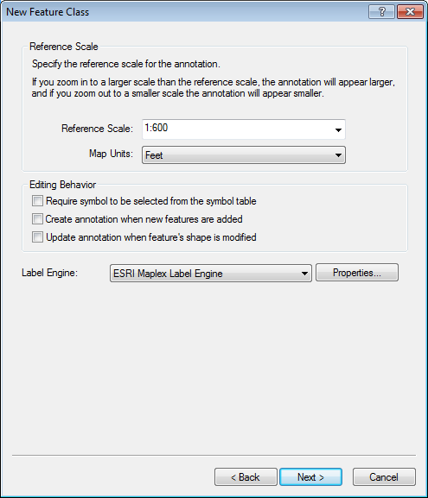

1. No additional changes are required. Click next through the below screens and finish.
2. Rename the relationship to “CrossSectionDir50AnnoRel”

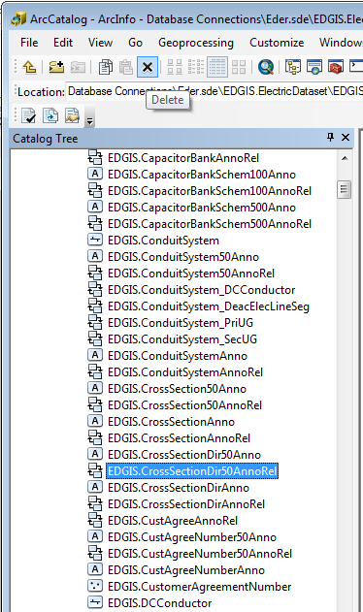

# Add GlobalIDs

1. Add GlobalID by right clicking the EDGIS.ElectricDataset and clicking “Add Global IDs…”
2. Click “Yes”

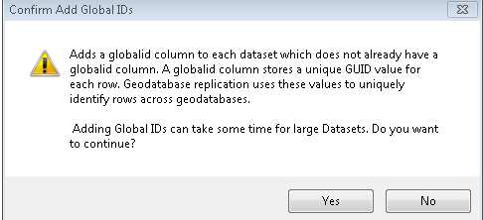

1. Observe GLOBALID has been added to the CrossSection50Anno, CrossSectionDirAnno and the CrossSectionDir50Anno feature classes.

# Apply Permissions

## Apply Permissions to the new Cross Section Annotation Classes

1. Right-click the ElectricDataset and select Privileges
2. Enter SDE_EDITOR for the role and select GRANT for View and Edit permissions
3. Click OK
4. Right-click the ElectricDataset and select Privileges
5. Enter SDE_VIEWER for the role and select GRANT for View permissions. Leave Edit blank.
6. Click OK
7. Repeat steps 4, 5 and 6 for the following roles:
   1. DAT_EDITOR
   2. DATACONV
   3. GIS_INTERFACE
   4. GISINTERFACE

# ArcFM Properties

## Make the ConduitSystem Direction field visible:

1. CrossSection50Anno
   1. In the ElectricDataset, right-click on the ConduitSystem feature class and select ArcFM Properties Manager
   2. Select the Field Info tab
   3. Find the Direction field and update the Visible property from No to Yes

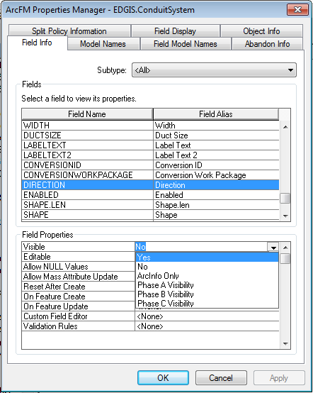

# Add Model Names

## Add Custom UFM Object Model Names to the Model Name Domain

* 1. Right-click on the database node and select Properties
  2. Select the Domains tab
  3. Find the Electric Object Class Model Name domain
  4. Add the following model names
     1. CROSSSECTION50: Cross Section 1:50 Anno
     2. CROSSSECTIONDIRANNO: Cross Section Direction Anno
     3. CROSSSECTIONDIR50ANNO: Cross Section Direction 1:50 Anno
  5. Click on OK

## Add Custom UFM Field Model Names to the Model Name Domain

* 1. Right-click on the database node and select Properties
  2. Select the Domains tab
  3. Find the Electric Field Model Name domain
  4. Add the following model names
     1. DIRECTION: Direction
     2. FEATUREID: Feature ID
  5. Click on OK

# Assign Model Names

1. Assign the following object level model names, autoupdaters, and properties on the following object classes:
   1. CrossSection50Anno
      1. Model name – CROSSSECTION50
   2. CrossSectionDirAnno
      1. Model name – CROSSSECTIONDIRANNO
   3. CrossSectionDir50Anno
      1. Model name – CROSSSECTIONDIR50ANNO
2. Assign the following field level model names to the following object class/field combinations:
   1. ConduitSystem
      1. Direction: DIRECTION
   2. CrossSectionAnno
      1. FeatureId: FEATUREID

# Update UFM Map Units

1. At the database level, right-click and select “ArcFM Properties Manager”.
2. In the Underground Facilities tab, modify the Map Size Miltipler from 12 to 18.

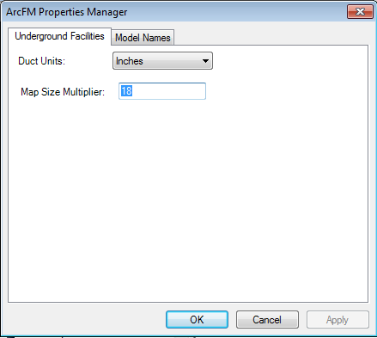

# Update Data Model Version Table

**Database Configuration:**

1. Open SQL Plus.
2. Log in using the same server and user as was used in section 2.  
     
   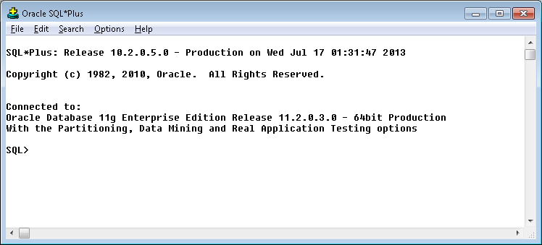
3. Run the SQL below:

update pgedatamodelversion set currentidc='N' where currentidc='Y';

insert into pgedatamodelversion (OBJECTID, CURRENTIDC, DATEAPPLIED, APPLIEDBYPERSONNAME, MODELVERSION) values (**INSERT NEXT VALID ID**,'Y',sysdate,'**<INSERT TEAM MEMBER DONE BY>**','**<INSERT DM VERSION>** GOLD **CR<INSERT CR NUMBER>**');

commit;

# Known Issues

<Please List any other issues encountered here while following the document>